Cambria County Election Board Officials Manual

Return the official copy of this manual in your Red Rolling Bag
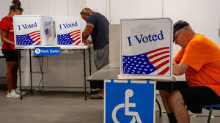
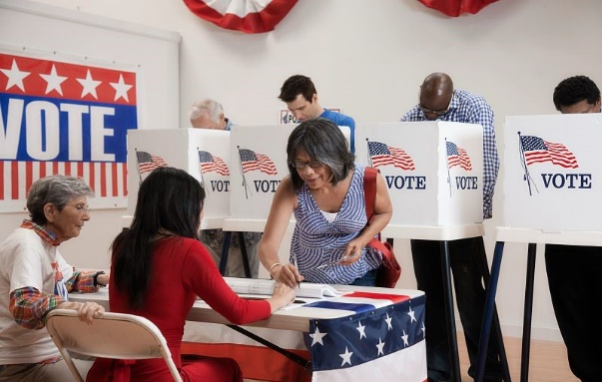

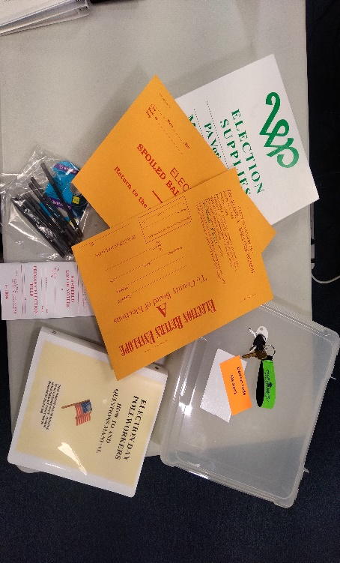
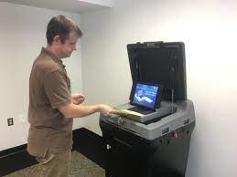

Contact information:
CAMBRIA COUNTY OFFICE OF ELECTIONS
CAMBRIA COUNTY COURTHOUSE
200 S. CENTER ST. EBENSBURG PA 15931

814-472-1460 OFFICE: Use for all regular Questions!

814-471-1809 (FOR POLL WORKERS ON ELECTION DAY EMERGENCY ONLY)

CONTENTS:
CAMBRIA COUNTY ELECTION BOARD OFFICIALS MANUAL
Introduction Letter
Important Notes to Remember
Section 0: Poll Worker Roles, Responsibilities, and Expectations
Expectations of All Poll Workers
Election Day Jobs
Rotating Jobs
Poll Worker Roles
The Election Board Officials
Poll Watchers
Section 1: Pre-Election Day Expectations and Preparations
1.0 – Pre-Election Day Preparations
Section 2: Election Day: Opening Setup
2.1 – Take Full Inventory
2.2 – Taking Oaths
2.3 – Set up the DS200
2.4 – Set up the ExpressVote
2.5 – Sign Affidavit of Voter Identification
2.6 – Fill out General Return of Votes Cast
2.7 – Fill out and Sign Pay Sheet(s)
2.8 – Post Exterior Signage
2.9 – Finish Setting Up the Check-in Table
2.10 – Prepare Judge’s Area
2.11 – Review Basic Procedures with the Team
Section 3: Election Day: Procedures and Processes
3.1 Polling Place Regulations
3.2 Election Watcher Rules
3.2.1 Inspecting Election Watcher Certificate
3.3 Campaigning/Political Activity Rules
3.4 Accounting Throughout the Election Day
3.5 Using the Poll Book
3.6 Using the NLV and Accounting Throughout the Election Day Using the NVL
3.7 Voting and Ballot Scanning
3.7.1 Spoiled Ballots
3.8 Voting on the ExpressVote
3.9 Check-in Issues
3.9.1 Voter Must Show ID
3.9.2 Voter is not in Pollbook or voter information is incorrect
3.9.2.A If a person’s name is not in the Pollbook, but it does appear on the PA Street List
3.9.2.B If voter insists, they are registered, but their name s not in the Pollbook, Pa Street list, or the supplemental Pollbook page.
3.9.2.C A voter presents a voters’ registration card and insists they are register to vote, but the name does not appear on any paperwork for the polling location.
3.9.2.D A voter presents a receipt from Penn Dot showing that they registered to vote when they updated or applied for their driver’s license. However, their name does not appear on any paperwork for the polling location.
3.9.2.E A The voter’s name and address in the Poll Book is incorrect.
3.9.2.F Voter is not in the Pollbook (other)
3.9.3 Voter needs to change address (in-county)
3.9.4 Voter needs to change address (out-of-county) and/or name
3.9.5 Fleeing Voter
3.9.6 Voting System Malfunction Log
3.9.7 Voter Listed as inactive
3.9.8 Absentee/Mail-in Voter at the Polls
3.9.8.A Absentee/Mail-in Voter DOES have ballot to surrender
3.9.8. B Absentee/Mail-in Voter DOES NOT have a ballot to surrender
3.9.8.C Absentee/Mail-in Voter HAS CAST A BALLOT
3.10 Voter Needs Assistance
3.11 Interacting with Person with a Disability
3.12 Provisional Voting
3.12.1 When a Provisional Ballot Can Be Issued
3.12.2 Instructions for Voting a Provisional Ballot
3.13 Voting in an Emergency
3.13.1 Physical Danger/Medical Emergency
3.13.2 Power Outage or DS200 Scanner Failure
3.13.3 Running Low on Ballots
3.13.4 Evacuating the Polling Location
3.14 Challenge of Voters on Election Day
Section 4: Election Day: Poll Closing Procedures
4.1 If the Emergency Bin was used:
4.2 Complete the General Return of Votes Cast Form and Pay Sheet(s)
4.3 Close DS200
4.4 Close ExpressVote Machine
4.5 Pack Provisional Ballots
4.5.1 Checklist if you did NOT issue any provisional ballots
4.5.2 Checklist if you DID issue any provisional ballots
4.6 Review Surrendered Material
4.7 Pack Remaining Materials
4.8 Seal Election Supply Bag (Red Rolling Bag)

Introduction Letter
Every Cambria County election is scrutinized, but the legal and media environment today amplifies the level of scrutiny. Every action you take on Election Day may eventually be scrutinized by the media, the courts, and the public.
We want every voter to have the utmost confidence in our elections. You and your colleagues - working together - ensure that your precinct's voters have a positive Election Day experience.
You ensure that voters are confident in our elections and that they have a positive experience by following every process and procedure to the letter. Following procedures means that the election results are accurate and there are no controversies.
On Election Day, you represent the Cambria County Government. We are very grateful to have professional and dedicated poll workers like yourself serving the citizens of Cambria County.
We have created this manual as a reference for you on Election Day. You must follow all election laws and procedures consistently for our elections to be successful, this manual will help you do that.
On behalf of the Cambria County Board of Commissioners-who also serve as our Board of Elections-I want to thank you for your time and your excellence. Working together, we will have a successful election in Cambria County.
Sincerely,
Nicole M. Burkhardt, Director of Election

Important Notes to Remember

- Your mantra on Election Day should be this: Follow the checklists and the procedures laid out in this Manual.
- Processes in this manual may be new to you but reflect the most up to date guidance. If these processes differ from your past experience, do not assume you should be doing it the way you have done in the past. Many items are in different locations than they were in previous elections. If you experience any difficulty, refer to the relevant section of this manual. Call the Elections Office (814-472-1460) if you have any questions or concerns.
- Any violation of the Election laws by any individual inside or outside of a polling place will be subject to a misdemeanor charge and if convicted, a Maximum fine of $1,000.00, ONE-year imprisonment, loss of voting privileges, and/or being banned from holding public office. Any election law violations received in writing will be immediately turned over to the District Attorney's Office.

Poll Worker Roles, Responsibilities, and Expectations

Expectations of All Poll Workers

Poll workers must adhere to strict guidelines to ensure impartiality. Impartiality is essential to free and fair elections. These expectations include:
- No political bias should be demonstrated in dress, manner, or appearance. This includes wearing political colors, symbols, stickers, and clothing with candidate names or explicit or implied references.
- Exercise restraint by avoiding discussing political matters with or without voter’s present.
- Arrive at the time designated by the Judge of Elections, at the very latest 6:00 am.
- Follow all protocol and procedures as outlined in this manual. If you have any questions or concerns with any information provided herein, call the Elections Office (814-472-1460).
Poll workers include the following job titles: Judge of Elections, Majority Inspector, Minority Inspector, Clerk, Machine Inspector, and Constable, and excludes campaign workers.

Election Day Jobs
Setting Up and Closing Down: Every poll worker should be involved with the setting up and closing process. The Judge of Elections is responsible for all paperwork, but any worker can assist in completing the paperwork.
Poll Book/Check-in/Numbered Lists: Two people are involved in the check-in process. One worker will write each voter's number in the Poll Book. One worker, with the Numbered list of Voters Booklet (NLV), will print the voters' names in the NLV. (Please use a Poll worker with the neatest handwriting)
Paper Ballot Management: One person should oversee un-voted ballots and giving ballots to voters. This person ensures that every voter receives only one ballot, a Standard Ballot or Express Vote Ballot. They may also spoil ballots.
Voting Machines: One person should oversee the Voting Machines, making sure voters are respecting one another's privacy. This person also ensures that voters have no issues scanning their ballots.
Provisional Voting: The Judge of Elections is responsible for provisional voting; however, other workers are involved in giving the voter a ballot and ensuring that the provisional voter does not scan their ballot.

Rotating Jobs
It is helpful to rotate jobs throughout the day so that everyone has knowledge of the various tasks that are done on Election Day. As workers take breaks during the election, other poll workers can fill in their position.

Poll Worker Roles
There are several different roles needed to run a polling location. These roles comprise two broad categories: The Election Board and Other Poll Workers. See table 1 for a breakdown of tasks and responsibilities for specific roles.

The Election Board Officials
Each precinct will have at least three (3) Election Board Officials. These officials are:
- The Judge of Elections
- A Majority Inspector; and
- A Minority Inspector.
The election board has more responsibilities than other poll workers (i.e., Machine Inspectors and Clerks). See Table 1 for more information on the Election Board roles.
Persons of the age of 17 are permitted to work at polling locations, but only as Clerks or Machine Inspectors and so long as they:
- Are a US Citizen and a Resident of Cambria County
- Are enrolled in a secondary educational institution
- Have written approval of a school representative; and
- Have written consent of a parent or guardian.

Poll Watchers
While poll watchers are not poll workers, they do have certain rights and privileges that poll workers should be aware of. However, poll watchers must meet certain criteria and abide by all regulations as outlined on their Watcher Certificate.
Be mindful that the poll watchers are there to watch and ensure election fairness and are an important part of the election process. Remember to be kind and courteous in your interactions with poll watchers and talk with the Judge of Elections or call the Election Office (814-472-1460) if you encounter any issues.
For more information on poll watchers (including all poll watcher rights, how the Judge of Elections should verify the poll watcher’s certificate, and what to do if poll watchers do not abide by established regulations), see Section 3.
Table 1: Poll Worker Responsibilities
Tasks | Role
Tasks | Judge of Elections | Majority Inspector | Minority Inspector | Clerk(s) | Machine Inspector | Constable
Materials | X
Assign Duties | X
Instruct Election Workers on Procedures | X
Maintain Order (Inside/Outside) | X |  |  |  |  | X
Poll Books | X | X | X | X | X
NLV | X | X | X | X | X
Assist with Voting Equip. | X | X | X | X | X
Issuing Ballots | X | X | X | X | X
Other Tasks as Needed | X | X | X | X | X
Keep Envelope B for 1 Year |  |  | X
Transport returns to drop off location | X |  | X
Misc. Notes | - works throughout the day;  - fills in for workers taking breaks  - Should be in polling location when DS200 is opened & closed | -fills in for workers taking breaks | - Should be in polling location when DS200 is opened & closed  -fills in for workers taking breaks | -fills in for workers taking breaks | - Primary Duty involves Assisting voters with Express Vote and DS200 machines. | - quell disturbance;  - keep polling place clear of political activities;  - assign deputies to cover their precincts

Section 1: Pre-Election Day Expectations and Preparations
If the polling location can accommodate it, we strongly encourage you to meet the day before the election to set up. This will make your life easier on Election Day. The Judge of Elections should contact the polling location to determine if access is possible the day before the election.
If the polling location cannot accommodate a visit the day before the election, follow the pre-election checklist on Election Day morning before beginning the Election Day opening checklist.

1.0 – Pre-Election Day Preparations
Checklist
- Take the Initial Inventory. Verify the following equipment in the space is included and is for your specific precinct. If you have received any items for other precincts or are missing items, call the Elections Office (814-472-1460) immediately. Equipment List:
  - DS200
  - Election Supply Bag (Blue Canvass Tote Bag)
    - Supply Box (White) which contains the:
      - Opening the Polls Procedures/Checklist
      - Postings Folder
      - Forms
      - Closing the Polls Procedures/Checklist
      - Pay sheets
      - Seals Sheet
  - Red Rolling Bag In the main pocket of the bag should be the
- Election Day Ballots
- Provisional Ballots
- Provisional Materials
- Express Vote Cards
- Orange Bag
- Peach Bag
- Blue Bag
- Black Bag
  - Black Soft-Sided Case, containing the Express Vote voting machine.
- Organize the space to determine the most natural flow through the voting process. Do the following:
  - Create a Natural Path. Create a natural path for voters to check in, vote, and cast their ballot, and exit, without crossing paths.
  - Place the Check-in Table. The Check-in table is where you receive and sign in voters. Place the table in a place where it creates a barrier between the public and poll workers.
  - Create a Voting Area. Make sure every voter will have privacy when voting and scanning their ballot.
  - Place DS200 according to your Voting Area.
  - Consider Security. Ensure that the DS200 is arranged so that they are visible to the poll workers and poll watchers.
  - ADA Accessibility. Make sure that your polling place is accessible. If you need to prop open the door, move something from the sidewalk, or take other actions to make the location accessible, please do so now if possible, or plan to do so before voting begins.
    - If you cannot address the ADA issue on your own, and the change can be made for the current election, call the Elections Office (814-472-1460).
    - If the issue cannot be addressed for the current election, enter a description of the issue on a note sheet from the front of your Poll books.
- Set up the Check-in Table and post Interior Signage.
  - Obtain the Election Supply Box inside (Blue Canvass Tote Bag). Inside the box you will find the Opening the Polls Procedures/Checklist, the Postings Folder, Forms Pay sheets, Seals Sheet and Closing Polls Procedures/Checklist.
  - As part of the Opening Procedures, do the following:
    - Place the PA Street List, Polling Location List, and NLV on the check-in table.
    - (Primary Only) Place Democratic and Republican Voter Cards near where the poll book will go.
  - Using the materials in the Postings Folder do the following:
    - Post all interior signage that is in the ‘Postings’ Folder. This includes the sample ballots and instructions to voters. It may be better to place postings on a spare table if one is available, especially if walls may be damaged by tape or push pins. If the location doesn’t allow for an extra table, use blue painters tape.
    - Post or place Informational Posters and Handouts. Post or place all Informational Posters and Handouts found in the ‘Postings’ Folder. Several of the posters/handouts have a cardstock copy for posting, and paper copies that can be kept near the poll books.
  - As part of placing the Forms do the following:
    - Place any forms you think you may need near where the Poll books will go for easy access (for example, the Cambria County Voter Registration Form)
  - (Optional) Make plans for breaks and food. Determine as a group how you will do meals. Discuss whether you each must bring breakfast, lunch, dinner, snacks, and drinks. Will you have a potluck? Will you order lunch together?

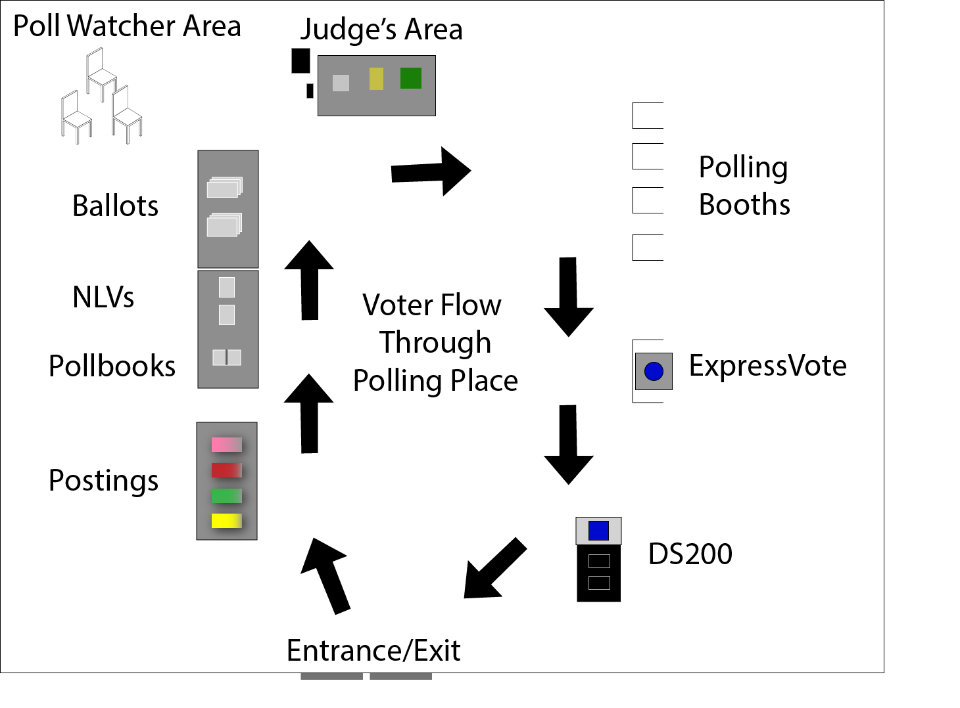

Example natural path plan through a polling place.
Example natural path plan through a polling place.
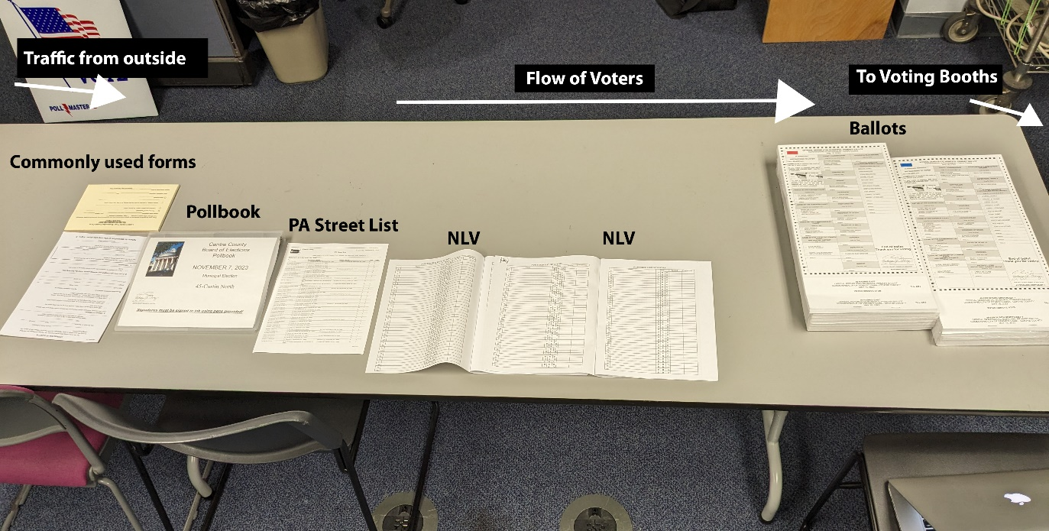

Only 1 NLV Book

Section 2: Election Day: Opening Setup
Checklist
Complete the following tasks and checklists before the polls open.
If you did not already complete the Pre-Election day checklist, do so now.
- 2.1 – Take full inventory to ensure you have received all needed supplies to open the polls.
  - During this process, Check Seals and Complete Opening Seal Sheet.
- 2.2 – Take oaths of office by completing the Election Officers’ Oaths form.
- 2.3 – Set up DS200.
- 2.4 – Set up the Express Vote.
- 2.5 – Sign, complete, and store Affidavit of Voter Identification.
- 2.6 – Fill out General Return of Votes Cast
- 2.7 - Fill out and Sign Pay sheet
- 2.8 – Post Exterior signage.
- 2.9 – Finish Setting Up the Check-in Table.
- 2.10 – Prepare Judge’s Area.
- 2.11 - Review Basic Procedures with the Team.

2.1 – Take Full Inventory
For this process, you will verify the precinct tags on all equipment (including the Express Vote) and all bags, including the content of the bags is for your precinct. The Judge of Elections, Majority Inspector, and Minority inspector must all be at the Polling Location before any Seals can be cut. If not all members are present, call the elections office (814-472-1460) immediately.
IF AT ANY POINT IN THIS PROCESS YOU FIND ITEMS MEANT FOR ANOTHER PRECINCT, CALL THE ELECTIONS OFFICE (814-472-1460) IMMEDIATELY.
Along the way, you will verify all Seals are intact and verify the number of the Seal on your Opening Seal Sheet. If ANY Seal is broken, CALL THE ELECTIONS OFFICE (814-472-1460) IMMEDIATELY FOR DIRECTION. You may need to snip the Seal to open the items when completing the inventory. See Opening Seal Sheet for further instructions.
See checklist on next page.

Checklist
- CONCURRENTLY Complete the first two parts of the Opening Seal Sheet.
- Obtain the Opening Seal Sheet which is within the Opening the Polls Supply Box (White).
- Verify that each Seal matches the number you have written on the Opening Seal Sheet.
- CONCURENTLY Verify precinct tags and contents of all the following items:
- One (1) Blue Canvass Tote Bag
  - Poll book
  - Election Manual
  - Supply Box (White). This box contains:
    - The Opening the Polls Procedures/Checklist
    - The Forms Packet
    - The Postings Folder
    - The Closing the Polls Procedures/Checklist
- One (1) DS200
- One (1) Red Rolling Bag :) which has a BLUE Seal and a GREEN Seal. If you have completed the Pre-Election Day Preparations, the BLUE Seal will have already been removed and taped on the Opening Seals Sheet.
Within this should be:
  - Election Day Blank Ballots (Make sure they are the correct Ballots)
  - Express Vote Ballots
  - Provisional Ballots(Make sure they are the correct Ballots)
  - Provisional Materials
  - Orange Bag
  - Peach Bag
  - Black Bag
  - Blue Bag
- One (1) Express Vote (located inside the Black Soft-Sided Case) which has a BLUE Seal. If you completed the Pre-Election Day Preparations, the BLUE Seal will have already been removed and taped on the Opening Seals Sheet.

2.2 – Taking Oaths
All election workers must take their oath of office upon arrival at the polls. The oath must be completed in duplicate and must be spoken out loud for all present to hear, including poll watchers if present. The Minority Inspector administers the oath of office to the Judge of Elections and the Judge of Elections then administers the oath to all others.

Checklist
Note: For any poll workers working a partial day, the Judge of Elections will administer the oath to them when they arrive and prior to the poll worker processing any voters.
- Complete both copies of the Election Officers’ Oaths form found in the Supply Box See picture below for example of how to fill out this form.
  - If all poll workers have taken their oaths and signed the Election Officers’ Oaths forms:
    - Place one (1) copy of the Election Officers' Oaths form into Envelope G, and then put this into the larger Envelope A for delivery to the County Board of Elections. Both envelopes are located in the Supply Box.
- Place the other copy of the Election Officers' Oaths form into Envelope H, and then put this into the larger Envelope B for the Minority Inspector.
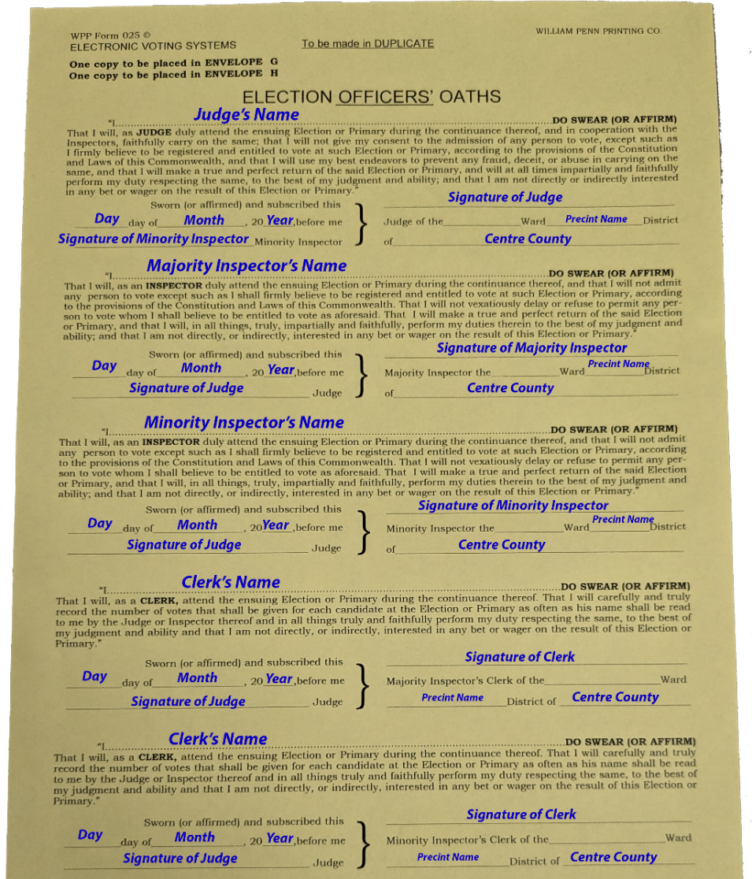

Cambria County

Cambria County

Cambria County

Cambria County
Cambria County

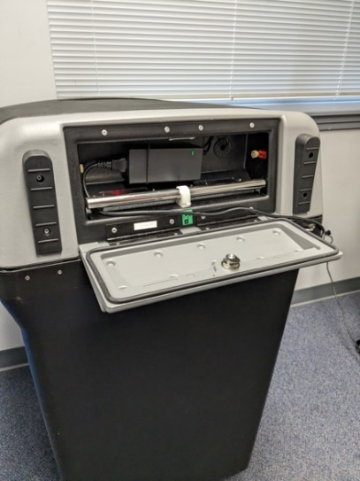
2.3 – Set up the DS200

Checklist
- Step 1
  - Acquire the Opening Seal Sheet (found in the Supply Box)
  - Acquire the Flat Key and using the Barrel Key ( Black
Bag)
  - Position machine according to your natural path plan.
  - Using the Flat Key, open the compartment on the back of the DS200.
  - Remove the plug from back compartment and plug into an outlet. Note, do not close the compartment while the machine is plugged in, so as not to crush the cord.
Back of DS200 with back compartment open.
  - Lock wheels in place.
- Step 2
  - Verify the Ballot Bin Compartment and the top cover of the DS200 are sealed.
    - If it is not sealed call the Elections Office (814-472-1460).
  - Remove the top BLUE Seal from the scanner area and tape this Seal number on your Opening Seal Sheet.
  - Verify the bottom BLUE Seal from the Ballot Bin Compartment and tape this Seal number on your Opening Seal Sheet.
- Step 3
  - The Emergency Bin
    - Record the Green Seal and Record on the Opening Seal Sheet
    - Do Not Remove the Seal

DS200 Note – Emergency Status
The Emergency Ballot Bin Compartment MUST remain locked and sealed at all times unless you are in an Emergency status. (Holds 250 ballots) If used a new Seal must be placed on the machine.
- Step 4
  - Unlock the top front with Flat Key and using the Barrel Key unlock the scanner and flip up the screen. The DS200 will automatically power up. Be patient, this process takes several minutes, and the screen will flash multiple times.
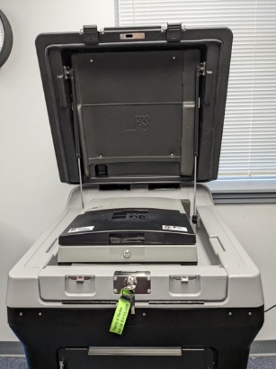
    - Note - If the DS200 does not automatically power up, unlock the access door on the front left and press and release the POWER button. Barrel Key Required.
- Step 5
  - Enter the Election Code (found in the Black Bag)
  - At this point, a Configuration Report will automatically print.
  - Place Configuration Report in Envelope A.
  - Make sure the screen shows a green check mark before “Election definition found”.
    - If no green check mark appears, check to make sure the USB stick is inserted properly into the machine. If this does not work, call the Elections Office (814-472-1460).
DS200 with the top open and the scanner down.
  - Make sure the screen shows a green check mark before “Plugged into Electricity.”
If no green check mark appears:
    - Check to make sure the device is plugged in. If it is, try moving it to a different outlet.
    - Check to make sure the power block cord is plugged in all the way.
    - If neither of these checks resolve the issue, call the Elections Office (814-472-1460).
  - Press “Open the Poll.”
  - The DS200 will automatically print 3 “Zero Tapes”. If you have issues with any tapes not printing automatically, press “Report Options” to print.
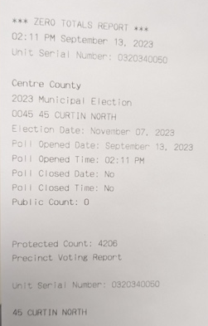
  - IF Zero Tapes do not print, call the Elections Office (814-472-1460). You must get a Zero Tape before using the DS200.

Zero Tapes. Tear along perforated lines between reports for all three copies.

  - Have each member of the election board sign all Zero Tapes.
  - Place one copy in Envelope A, another copy in Envelope B, and the third copy in the Black Bag. This third copy must be available for inspection during the day.
  - Ensure the Public Count is zero. If it is not, call the Elections Office (814-472-1460) immediately.
  - Ensure the Date, Time, Election, and Precinct are all accurate.
  - Press “Go to Voting Mode.”
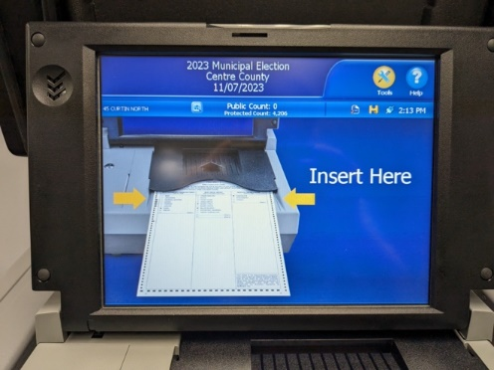
The DS200 is now ready for voting.

DS200 Ready Screen

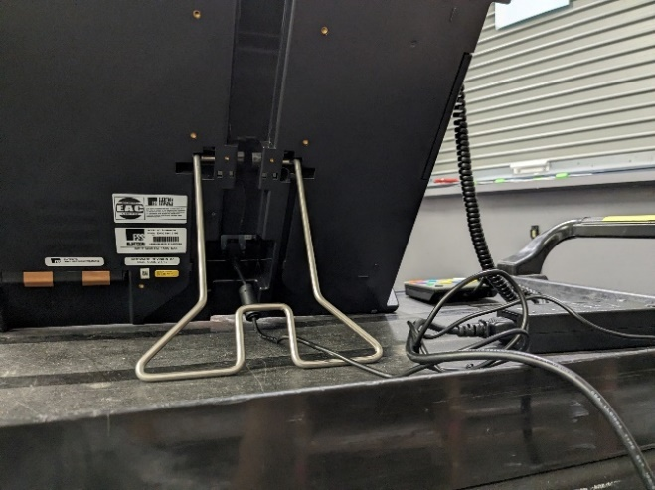

2.4 – Set up the Express Vote

Checklist
- Acquire the Election Code (found in Black Bag).
- Acquire the Flat Key and using the Barrel Key (Black Bag)
- Remove the BLUE Seal from Black Soft-Sided Case and verify that this Seal number matches the number on your Opening Seal Sheet. Tape Seal on Opening Seal Sheet.
- Stand the unit up on the table using the kick stand on the back. Plug the Express Vote power cord into the back of Express Vote and then into AC outlet.
Back of Express Vote with kickstand up and power cord running to outlet.
- Using the Barrel Key, open the left side access compartment and verify the Election Definition Media Stick is plugged in.
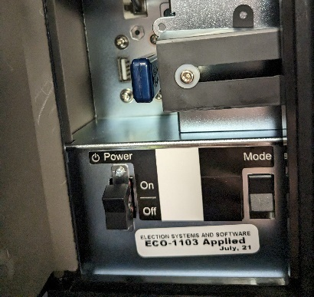
- Flip the Power Switch to the ON position. Note: The system startup takes several minutes, and the screen will flash multiple times.
- For accessible voting, the keypad is located on the left side access compartment and headphones are in the side pocket. Plug in the headphones and place both items in front of the unit. Do not unplug the keypad.
- Enter the Election Code then touch Accept.
- Verify that the CORRECT precinct is noted on the top of the screen. IF there is a discrepancy IMMEDIATLETY call the Elections Office (814-472-1460). If no discrepancy, touch OK to display the Voter Welcome Screen.
- Check to make sure that there are green lights on at the bottom of the unit near the accessible input areas. This will confirm that the unit is plugged into power and that the battery is charging.
Left access compartment displaying power switch and media stick.
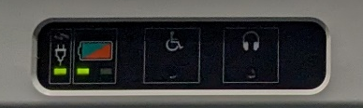
- Confirm the date and time are correct at the top of the screen.
The Express Vote is now ready for voting.

Lights confirming unit has power.

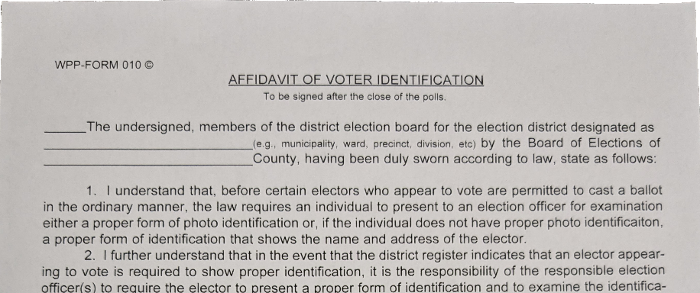
2.5 – Sign Affidavit of Voter Identification
Top of Affidavit of Voter Identification Form
All poll workers must sign the Affidavit of Voter Identification. You will sign this form once in the morning stating you will check ID for every voter that it is required for and once at the end of the day that you did in fact check each voters ID.
By signing this form, you affirm that you will check ID for any person identified in the poll book as needing to show ID.

Checklist
- Locate Affidavit of Voter Identification, found in the Supply Box.
- Each poll worker signs the Affidavit of Voter Identification.

Once each poll worker has signed, Place Affidavit of Voter Identification in Envelope A

2.6 – Fill out General Return of Votes Cast

Checklist
  - Obtain 2 copies of the General Returns of Votes Cast from the Supply Box (blue canvass tote bag).
  - Fill out line 1 of Column-B in the Election Day section. See picture below.
    - Check this number against the number of ballots on the sticker provided with the ballots. If the numbers do not match, call the Elections Office (814-472-1460).
  - Repeat with the Express Vote Ballots in the Express Vote Ballots section (this number can be Label)
    - Note: if you receive additional ballots throughout the day, write the number received in Column – B below the starting number. You will total the amount of ballots received in the total section at the end of the day.
  - On the General Returns of Votes Cast forms, fill out the first line of the Provisional Ballots section with the number of provisional ballots you received. DO NOT REMOVE THE SEAL! This number will be on a sticker on the ballots.
  - Then, do this on all three copies and set aside till the end of the day
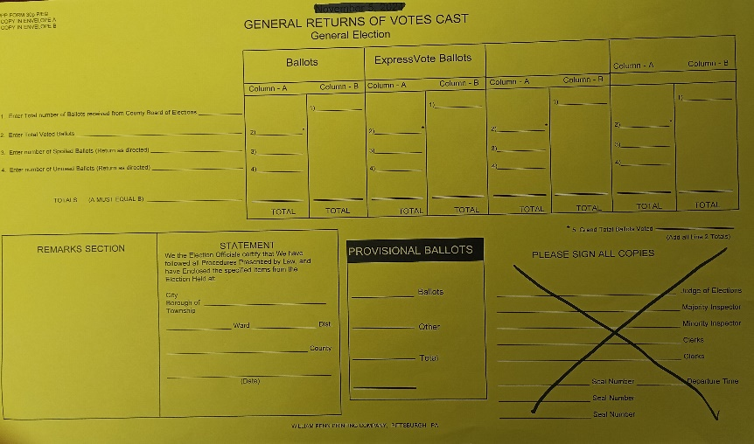
Enter the number of Provisional Ballots received on the top line.
50

FOR SIGNATURES ONLY: DO NOT RECORD SEAL NUMBERS
50

350
Enter the number of Express Vote Ballots received in column B- in the Express Votes Ballot Area. Number on envelope label.

Record the number of Ballots from the sticker in Column B

2.7 – Fill out and Sign Pay Sheet

Checklist
- Locate Pay Sheet(s), found in the Supply Box.
- Each poll worker should fill out their section.
- Once each poll worker filled out their section, the Judge of Elections should confirm all information is correct.
  - If all poll workers filled out the Pay Sheet:
    - Place Pay Sheet(s) in Blue Canvass Tote Bag.

2.8 – Post Exterior Signage

Checklist
- Place all signage that goes outside the polling location according to your developed plan. Ensure signage is placed in an area that the voters can see before entering the polling area.

2.9 – Finish Setting Up the Check-in Table
Most of the check-in table should be set up at this point (refer to 1.0 - Pre-Election Day Preparations Checklist).

Checklist
- In the Blue Canvass Tote Bag should be the Poll book.
- Place the Poll book and the Ballots on the Check-in Table.

2.10 – Prepare Judge’s Area
The Judge’s area is your secure location, separate from the natural path the voters will take through the space. In this area, you can store all extra materials and supplies (e.g. Election Supply Bags (Orange, Peach) (Red Rolling Bag), the Black Bag, Blue Bag, forms, envelopes). Organize this space as best you can so you can find what you need during the day when you need it.
This space can be used for completion of paperwork throughout the day as time allows. For example, the Judge may organize and fill out the various Envelopes here before the end of the day.

Checklist
- Place all remaining supplies and materials in the Judge’s Table area. This includes provisional materials if you do not have another designated space.
- Organize the area as needed.

2.11 – Review Basic Procedures with the Team
As time allows, review procedures with the team. For example, discuss who has or does not have experience with particular procedures (i.e. voting provisionally, interacting with voters with disabilities, emergency procedures) and review procedures as needed. See Section 3 for all voting day regulations, procedures, and processes for inspiration and reference.

Section 3: Election Day: Procedures and Processes

3.1 Polling Place Regulations
It is important to keep order at the polls and to ensure that activities run on time. Follow these rules and things should run smoothly.
- Open at 7 am: Regardless of any issues you are having with opening, you must open at 7 am. If you have Poll Book(s), ballots, and NLV, then you can have an election!
- Close at 8 pm: any person in line before 8 pm-either inside or outside the polling place-can vote if they are qualified. If you have a line, put a poll worker at the end of the line so you know who the last legal voter is. If possible, pull the line inside and lock the door.
- Limits on Who can be in the Polling Place: Until the polls are closed, the only people who can be in the polling place are: (1) Election Board Workers, (2) Constable, Watchers, and voters who are waiting to vote (along with children or a caregiver providing legal assistance).
- Constables are the only authorized peacekeepers on Election Day that should remain at the polling location.
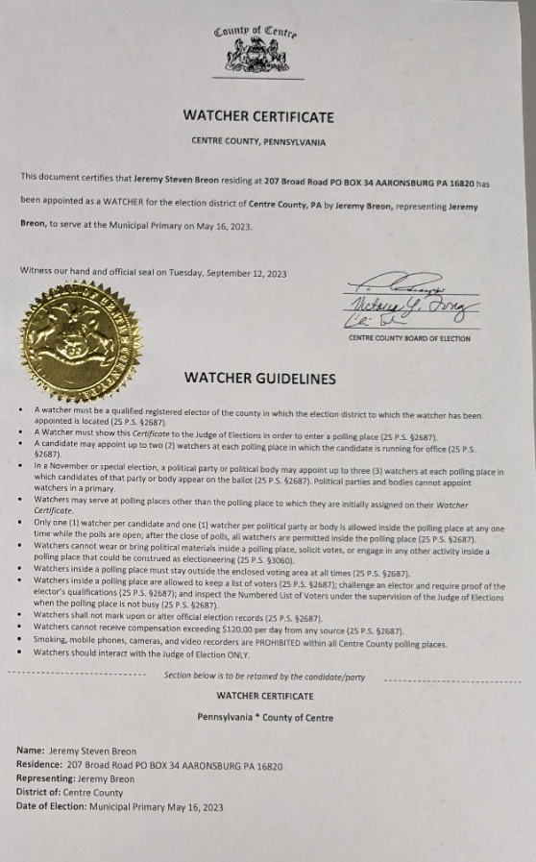
- If you notice the line is impeding building operations or causing confusion, you can limit the number of voters in the polling place or adjust the queue as necessary to resolve the issue. For example, you can direct voters to queue outside of the voting place to not block a hallway.
Watcher Certificates may look different then pictured below

3.2 Election Watcher Rules
At every precinct of November Elections, each political party can have three (3) watchers and each candidate can have two (2) watchers.
- When the polls are open, each candidate and each political party can have only one (1) watcher in the polling place at any one time. The person inside the polling place can change over the course of the day. While the polls are closed, all watchers can be in the polling place.
- The poll watcher must present their Watcher’s Certificate to the Judge of Elections in order to enter a polling place. The Watcher’s Certificate stays with the watcher (it is not taken or stored by the Judge of Elections).
- If an Election Watcher breaks any rules, the judge of Elections should try to resolve the issue. If the issue cannot be resolved, call the Elections Office (814-472-1460).

Example Election Watcher Certificate
Election Watchers CAN:
- Be inside the polling location, so long as they remain outside the area where voters are voting. If possible, provide them a place to sit within 6 feet of the check-in table.
- Bring their own listing of voters registered in your precinct.
- Challenge a voter's eligibility to vote. Follow process 3.14 if this occurs.
- Ask you to speak louder when calling out the names of the voters.
- Be inside the polling location after the polls close.
- Inspect the NLVs under the supervision of the Judge of Elections when there are no voters voting.
Election Watchers CANNOT:
- Be near voters during the voting process.
- Wear or bring political materials into a voting place, solicit votes, or engage in any other activity inside a polling place that could be construed as electioneering.
  - This includes talking to voters.
- Mark or alter official election records.
- Ask procedural questions of the poll workers. If they have procedural questions, they can ask the Judge of Elections.
- Be given copies of any materials used during the day (this includes paper copies of forms, envelopes, ballots, etc.).
- Use mobile phones, cameras, or video recorders within the polling place.
- Smoke in the polling place.

3.2.1 Inspecting Election Watcher Certificate
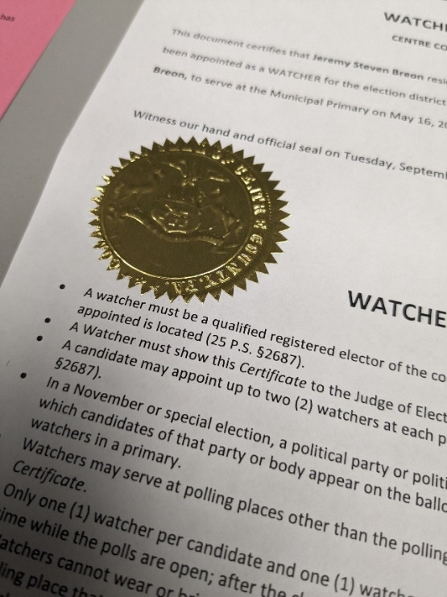
Whenever an Election Watcher enters the polling place and identifies themselves to the poll workers, the Judge of Elections should:
- Ask to see the Watcher Certificate.
  - Be sure to check for the embossed county seal on each certificate. The seal may not be gold, but it will be RAISED.
- Ask to see a person’s identification and check their identity against the name on the watcher certificate. However, the watcher is not required to provide identification.
- Each candidate and each political party can only have one (1) watcher in the polling place at one time. If the watcher is representing a political party or a candidate that already has a watcher in the polling place, ask one of the watchers to leave.

Raised seal on a watcher certificate

3.3 Campaigning/Political Activity Rules
Candidates and campaign volunteers are permitted to distribute handouts to potential voters if it is done TEN (10) feet or more from the door to the polling room. Any candidate or political materials may be posted if they are approved by the facility and they are posted at least 10 feet from the polling room. The outside campaigners cannot impede voter pathway to the polling location. If this becomes a problem, have the Constable address the campaigners. If you do not have the contact information for the Constable or you do not have a Constable, call the Elections Office (814-472-1460).
Voters may wear campaign buttons, stickers, hats, and items of clothing displaying campaign information inside of the polling place.
Voters cannot engage in active electioneering, which includes, but is not limited to, encouraging others inside the polling place to vote for one candidate or another.

3.4 Accounting Throughout the Election Day
Every hour or as practical, stop and ensure that the numbers in your precinct (across the NLV, across the DS200 public count, and across the ballots issued) are all in sync.

To check synchronicity:
- NLV:
- Public Count/ NLV:
  - Compare the Public Count on the DS200 with the number in your NLVs.
  - If the numbers do not match, then troubleshoot the problem.
    - For example, if a voter receives a provisional ballot, that number will not be in the count on the DS200. Spoiled ballots and provisional lines should be in RED PEN.
- Public Count/Ballots Issued:
  - Ensure that the Public Count on the DS200 matches the total number of ballots plus the number of Express Vote Ballots issued MINUS the number of spoiled ballots.
For Example, 20 ballots, 2 Express Vote Ballots, 4 spoiled ballots = 20+2-4 = 18 ballots listed on the DS200’s Public Count.

3.5 Using the Poll Book
Note, when using the Poll Book, be mindful to check the supplemental pages whenever issues arise. The supplemental pages, found in the back of the poll book behind a colored sheet, include voter record changes that happen in the last few days before the election, after the poll book has been printed.
- When a voter arrives, one worker will ask them to state their name.
- Look up the voter in the Poll Book. The worker should repeat the voter's name loud enough so it can be heard by all officials and any watchers who may be present.
- If there is a watermark in the signature box, see Section 3.9 – Check-in issues to continue.
- Ask voter if their address is correct.
  - If the voter's address is correct, they should sign the Poll Book in the designated space. Use Blue Pen.
  - If the voter’s address is not correct, see Section 3.9.3 before continuing.
- After the voter signs the Poll Book, the worker with the NLV will legibly print the voter's name in their NLV. Use the PA Street List to ensure you are spelling the person's name correctly if necessary.
- Lastly, write the corresponding NLV voter number into the “Voter #” section of the Poll Book.

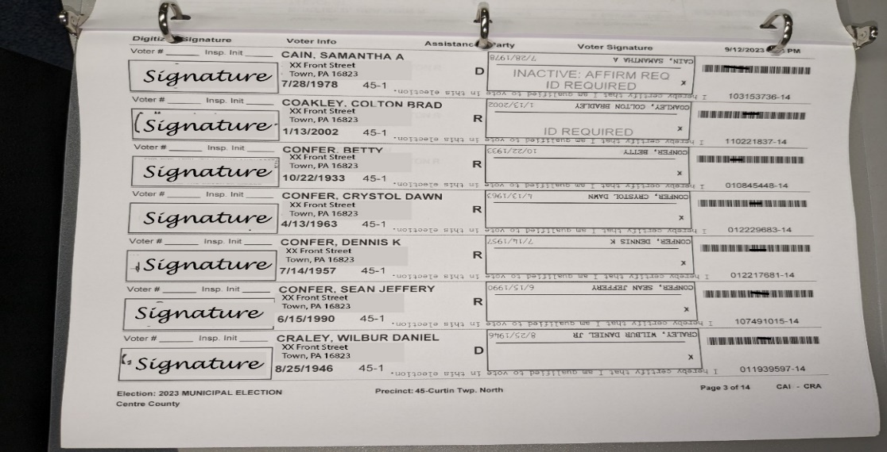
Example of a poll book page

3.6 Using the NLV and Accounting Throughout the Election Day

Using the NLV
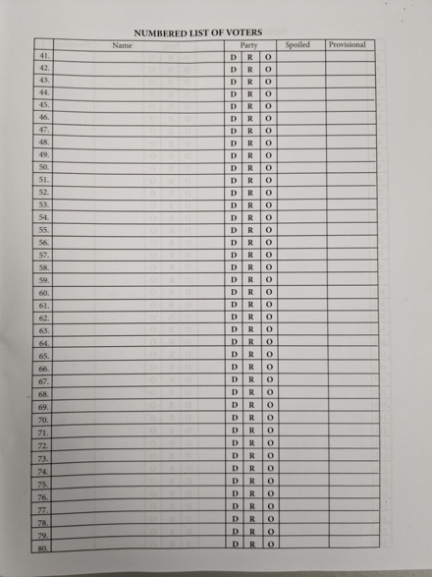
There is one NLV and it must remain consistent. As each voter is checked in, the poll worker that is responsible for an NLV should mark the name and mark the party (if primary). They will also mark in the NLV if a ballot needs to be spoiled (see process 3.7.1) or a provisional ballot is issued (see process 3.12). If a voter is issued an Express Vote Ballot, keep a running tally one the back of the General Return Votes Cast Sheet.
Example NLV
Do NOT use pencil/eraser or whiteout. Any corrections made should be done with a red pen including cross out writing, as the Elections office needs to be able to determine what corrections were made!

3.7 Voting and Ballot Scanning
Once the voter has signed the Poll Book, use the following process.
- Give the voter their ballot.
- Let them know that, once they finish voting, they can proceed to the DS200, and scan the ballot.
- Let them know if they make a mistake they can come back and get a new ballot.
  - If the voter makes a mistake, spoil the ballot (process 3.7.1).

3.7.1 Spoiled Ballots
Some voters will make a mistake voting and need a new ballot. In this instance, do the following.
- Spoil the ballot by writing "SPOILED" across the ballot and drawing a line down the black boxes on the left side of the ballot.
- Place the spoiled ballot in the Spoiled Ballot Envelope located in the Supply Box
- Place an "X" in the SPOILED column of the NLV. Use Red Pen.
- Issue the voter a new ballot marking that new number in the NLV on the next open line.
- If you must spoil 2 ballots by the same voter direct them to use the Express Vote (3.8) to vote.
During closing place, the Spoiled Ballot Envelope in the Peach Bag.

3.8 Voting on the Express Vote
Any voter can use the Express Vote machine. We highly recommend the Express Vote for voters who spoil a Standard ballot, voters you know have vision issues, and voters who may have a visible tremor in their hands. To vote on the Express Vote Machine, do the following.
- Give the voter an Express Vote Ballot.
- Have the voter insert the Express Vote Ballot into the Express Vote.
- If the voter is having difficulties viewing the screen of the Express Vote, use the zoom and contrast buttons at the bottom the screen.
- Have the voter make their selections and review their choices (give them privacy while making their selections).
- Have the voter select print when they are finished.
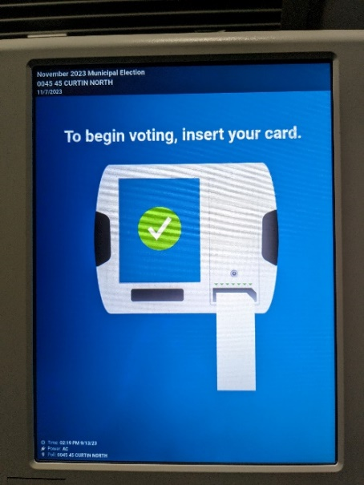
- Have the voter take the printed ballot and insert it into the DS200.
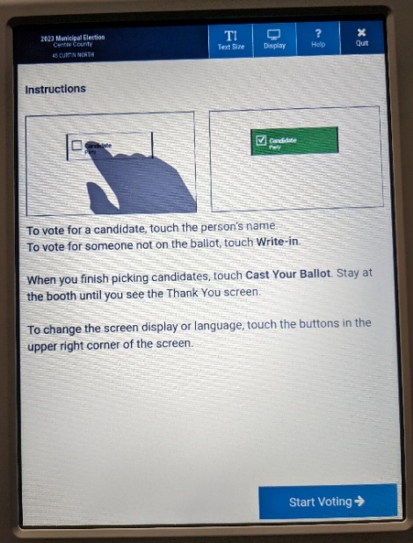
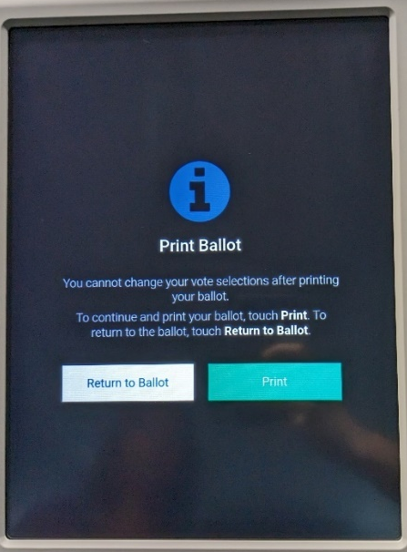
Insert Express Vote ballot as depicted on the screen.

Once the voter's choices are confirmed, press print.
Follow instructions to begin voting. If desired, adjust visual settings using the touchscreen buttons at the top of the screen.

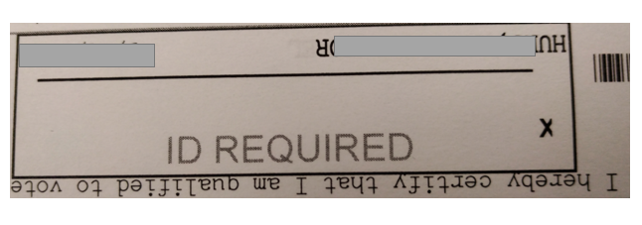
3.9 Check-in Issues

3.9.1 Voter Must Show ID
If the voter is new to their precinct or voting for the first time-even if they have voted in other Cambria County precincts-the Poll Book will note that they must show identification.
Once they show ID for verification, they sign the Poll Book and are checked in normally.
Approved forms of identification include:
PHOTO IDENTIFICATION | NON-PHOTO IDENTIFICATION
Pennsylvania driver's license or Penn DOT ID card | Confirmation issued by the County Voter Registration Office
ID issued by any Commonwealth agency | Non-photo ID issued by the Commonwealth
ID issued by the U.S. Government | Non-photo ID issued by the U.S. Government
U.S. passport | Firearm permit
U.S. Armed Forces ID | Current utility bill
Student ID | Current bank statement
Employee ID | Current paycheck
 | Government check
If a voter who is required to show ID in your precinct CANNOT provide ID, the voter MUST cast a provisional ballot (See Process 3.12 for more information).
In addition to following the provisional ballot process, give the voter the Provisional ID Affirmation form located in the Provisional Materials. This form has instructions on how the voter should submit a copy of their ID to the Election Office. In short, the voter can email, fax, deliver, or mail a copy of ID to the Elections Office by the Monday after the Election at 5:00 PM and they will count the provisional ballot once we have confirmed their identification. If no ID is provided the provisional ballot will not count.

3.9.2 Voter Not in Poll Book or Voter Information is Incorrect

3.9.2. A If the person's name is not in the Poll Book, but it does appear on the PA Street List.
The Judge of Elections should contact the Elections Office (814-472-1460) to check the correct district of the voter.

3.9.2. B A voter insists they are registered, but their name is not in the Poll Book, PA Street list, or the Supplemental Poll Book Pages.
- Ask the voter if they changed their name.
  - If they did change their name:
    - The Judge of Elections should call Elections Office (814-472-1460).
    - If the Elections Office reports that the Voters' Registration Website, states that the voter’s previous name appears on the computer, have the voter fill out a Cambria County Voter Registration Form and allow them to vote if their previous name appears in the poll book.
      - If they do so, place the completed form in the Envelope C found in Supply Box.
  - If they report they did not change their name, call the Elections Office (814-472-1460) for further instruction.

3.9.2. C A voter presents a voters' registration card and insists they are registered to vote, but the name does not appear on any paperwork for the polling location.
A voter's registration card does not indicate the person is currently registered to vote. The office may have received notification that the voter is no longer eligible to vote (due to cancellation for inactivity or to a move to another county).
- Ask the voter if they changed their name or address.
  - If they did change their name or address:
    - The Judge of Elections should call Elections Office (814-472-1460).
    - If the Elections Office reports that the Voters' Registration Website, states that the voter’s previous name or address appears on the computer, have the voter fill out a Cambria County Voter Registration Form and allow them to vote if their previous name appears in the poll book.
        - If they do so, place the completed form in Envelope C found in Supply Box.
  - If they report they did not change their name or address, call the Elections Office (814-472-1460) for further instruction.

3.9.2. D A voter presents a receipt from Penn Dot showing that they registered to vote when they updated or applied for their driver's license. However, their name does not appear on any paperwork for the polling location.
Generally, this occurs when the date on the Penn Dot receipt is after the cut-off date and the registration could not legally be processed for the current election. The registration form (if it has been received from Penn Dot) is being held until the opening of the next registration. Do not argue, just allow them to vote Provisional.
- The Judge of Elections should call Elections Office (814-472-1460) to confirm the voter status.

3.9.2.E The Voter’s name or address in the Poll Book is incorrect.
This can occur when a voter has moved from their election district and did not notify the Voters' Registration Office. The voter may go back to the former polling location to vote ONE LAST TIME.
- Direct the voter to go to their former polling location to vote.
- The location in which the voter is registered, should have the voter complete a Cambria County Voter Registration Form with the new address, if remaining in Cambria County (If moving out of county (see process 3.9.3). This will allow the Voters’ Registration office to update the address for the next election.
- Last, place the completed form in Envelope C in the Supply Box.

3.9.2. F Voter is not in the Poll Book (other)
- The Judge of Elections should call the Elections Office (814-472-1460) for further instructions. The Elections Office will use the State voter registration database to determine if the voter is registered and in which precinct they should vote.
- If the voter is not registered, you may give them a Voter Registration Form located in the Supply Box. Even if they complete the form the only way they can vote is by PROVISIONAL!
  - If they complete the Voter Registration Form, place the completed form in Envelope C in the Supply Box.

3.9.3 and 3.9.4 Voter needs to change address (in-county) and (out-of-county) and/or name
If they are moving outside of Cambria County or are currently registered in another county or need to change their name a Voter Registration Application form MUST be used.
- Have the voter fill out the Voter Registration Application form. These forms can be found in the Forms Packet (Yellow).
- Place the completed form in Envelope C in the Supply Box.
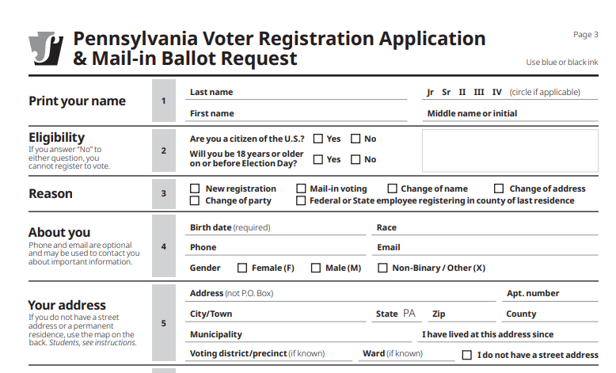

3.9.5 Fleeing Voter
If a voter leaves without casting their ballot:
- Put a single line through their name (Use Red Pen) in the NLV and notate fleeing voter beside their signature in the Poll Book and NLV.
- Spoil the ballot by writing “SPOILED - FLEEING VOTER” on the ballot.
- Place the ballot in the Spoiled Ballot Envelope.

3.9.6 Voting System Malfunction Log
If an issue arises that causes a piece of equipment to be unusable or a voter makes a complaint:
- Using the Voting System Malfunction Log, insert the details requested.
- Form is in the Supply Box.
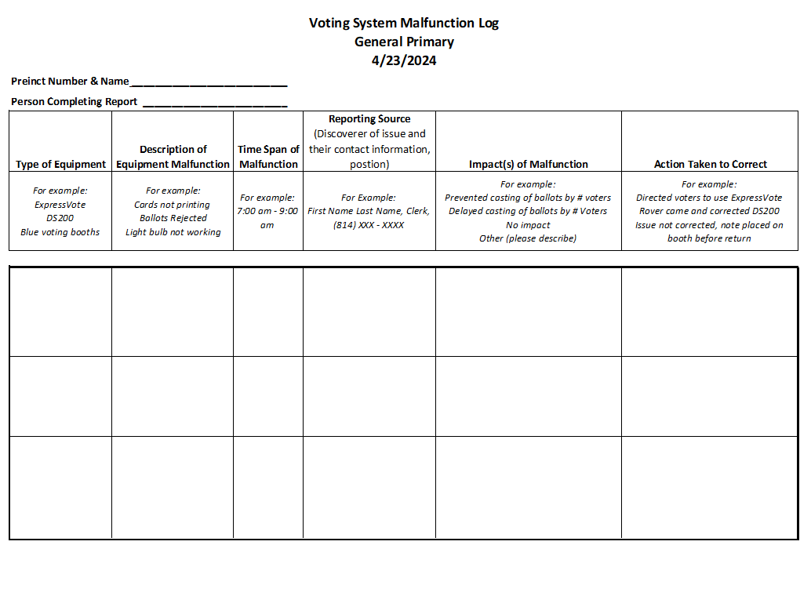

3.9.7 Voter Listed as inactive

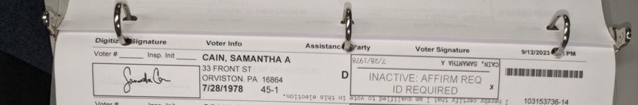
Address
Signature
Poll book entry with “Affirmation/ID Required” instruction

Top of Affirmation of Elector Form
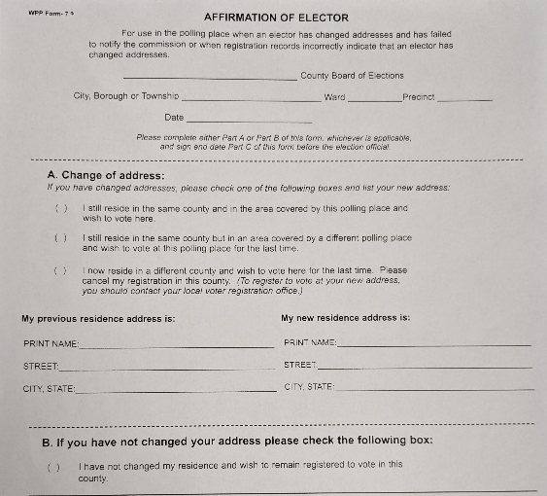
If the Poll Book has ‘Inactive: Affirmation required’ in the signature area, it indicates they haven’t voted in several elections. Do the following:
- Have the voter complete the top part of the Affirmation of Elector Form and then either Part A or Part B.
- The voter and an election official complete Part C together.
- Once the form is complete, the voter can then be checked in normally. Place forms in Affirmation of Elector Envelope.
If it reads both ‘Inactive’ and ‘Affirmation required’ and the voter has moved or changed names
- Have the voter fill out a Cambria County Voter Registration Form.
- Make sure the apartment number is listed on the Cambria County Voter Registration Update Form, if applicable. Also, the voter MUST have a physical address which includes a street name. They may additionally have a mailing address as a P.O. Box. Ask if there is a P.O. Box to be used as a mailing address. They CANNOT use a stand-alone P.O. Box, UPS, or USPS address to register to vote.
- Place the completed form in Envelope C in the Supply Box.
- Have the voter complete both forms.
Place all necessary forms in Envelope a when completed.

3.9.8 Absentee/mail-in voter at the Polls

3.9.8.A Absentee/Mail-in Voter DOES have a ballot to surrender
If the Poll Book shows “Remit Absentee/Mail-in Ballot or Vote Provisional”:
- Ask the voter if they brought their official absentee/mail-in ballot and official ballot return envelope to the polling place.
- If a voter comes to the poll with (1) their absentee/mail-in ballot and (2) the Purple Official Ballot Return Envelope with their name on it, they will vote a STANDARD BALLOT after following these steps:
  - Take their absentee/mail in ballot, and declaration envelope from the voter.
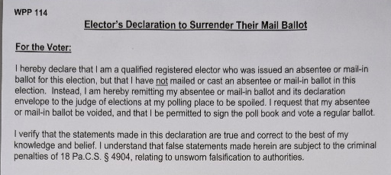
  - Spoil the Mail-in/Absentee ballot by writing “spoiled” on it. It does not matter if the ballot is blank or is partially/fully voted.
  - Have the voter sign the Elector’s Declaration to Surrender Their Mail-in Ballot form.
  - Place the ballot, Purple Official Ballot envelope, and the Surrender Declaration form together and place them in the Surrendered Absentee/Mail-In Ballot Bag (Orange Bag).
  - Once they have surrendered and signed, check them in like a regular voter.
Top of Elector’s Declaration to Surrender Their Mail-in Ballot form.
  - If missing their absentee/mail-in ballot OR their Purple Official Ballot envelope, they MUST VOTE by PROVISIONAL. See Process 3.12.

3.9.8.B Absentee/Mail-in Voter DOES NOT have a ballot to surrender
- If the Poll Book shows “Remit Absentee/Mail-in Ballot or Vote Provisional” BUT they don’t have (1) their absentee/mail-in ballot and (2) the Purple Official Ballot Return Envelope, they can only vote by provisional. See Process 3.12.

3.9.8.C Absentee/Mail-in Voter HAS CAST A BALLOT
- If the poll book says: “Ballot Cast/Not eligible” This indicates that the County has already received the voter’s absentee or mail-in ballot. The voter has already voted in the election. However, the voter always has the right
to vote using a provisional ballot if they feel their ballot will not be counted and they request a provisional. See Process 3.12.

3.10 Voter Needs Assistance
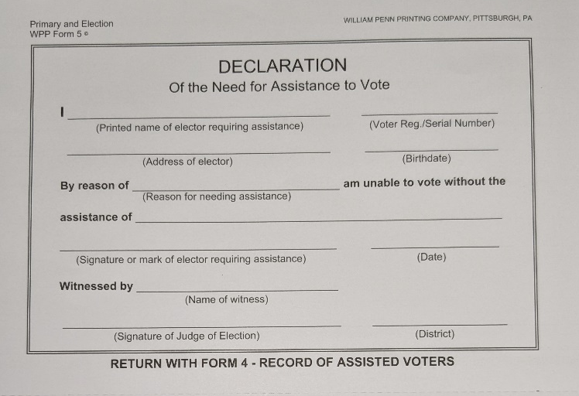
Any voter can receive assistance if you have them/their caregiver complete the Declaration of the Need for Assistance to Vote form that is in your Supply Box. If someone asks for assistance, let them receive assistance. Use the following process.
- Have someone complete the Declaration of the Need for Assistance to Vote form.
- Ensure that the poll worker helping the voter is not their employer, an agent of their employer, or an officer or agent of the voter's union or Judge of Election.
- The Judge of Elections or another worker should complete the Record of Assisted Voters found in your Supply Box. Required information includes:
  - the voter's name and voter number from the Poll Book,
Declaration of the Need for Assistance to Vote form.
  - a statement of facts which entitle them to assistance ("REQUESTED ASSISTANCE" is sufficient), and
  - The name of the person furnishing the assistance.
Note on providing “statement of facts which entitle them to assistance.”
The Elections Office uses assisted voter information to follow up with voters needing assistance so we can serve them most effectively. At a minimum, write ‘requested assistance’ on the Record of Assisted Voters so we can contact these voters if necessary.
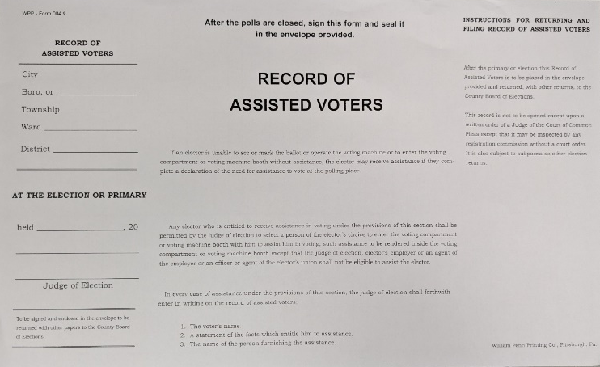

Record of Assisted Voters form.

3.11 Interacting with Person with a Disability
- When talking to a person with a disability, look at and speak directly to that person, rather than their companion. Do not speak loudly and slowly to an individual unless you know that doing so is necessary to communicate.
- If a person has a service animal, do not pet or play with the animal. This may unsettle the person and may interrupt the animal from doing its assistive duties.
- Let a person with a disability ask for help. Do not assume the needs of a person with disabilities. If the voter asks for help inquire on how you may be of assistance.
- Communicate clearly and comprehensibly. Be sure to convey your message in an understandable form and in multiple ways if necessary.
- Do not ask about a person's disability. Focus on what the person is communicating to you.
- In your conversation, relax. Don't be embarrassed if you happen to use accepted common expressions such as "See you later" or "Got to be running along" that seem to relate to the person's disability. Don't be afraid to ask questions when you are unsure of how to assist the person.
- If a person has a visual disability, greet the person verbally to let them know that you have approached them. Identify yourself and others who may be with you. Speak normally, facing the person.
- Never grab a person's arm, cane, or wheelchair, assuming they need assistance. Ask first if they need assistance. If a person needs assistance, offer your arm as a guide, and describe any obstacles in the path of travel. When arriving at the destination, orienting them (e.g., explain the Express Vote machine). Verbally let them know when you are leaving, or the conversation has ended.
- If a person has a speech disability, listen attentively and be encouraging, not correcting. Exercise patience rather than attempting to speak for a person with a speech disability. Never pretend to understand if you are having difficulty doing so. Repeat what you understand or incorporate the person's statements into the follow-up questions. The person's reactions will guide you. When necessary, ask short questions that require short answers, a nod, or a shake of the head.
- When talking at length to a person who uses a wheelchair, sit in a chair or crouch to put yourself at the person's eye level to facilitate conversation.
- A person's disability may not be readily apparent. For example, people with brain injury, epilepsy, mental illness, autism, or developmental disability are often misunderstood because of their behaviors or ways of communicating. Remember to be patient with all voters.

3.12 Provisional Voting

3.12.1 When a Provisional Ballot Can Be Issued
Anyone who appears to vote in an election district must be provided the opportunity to cast a provisional ballot if:
1. They are listed as requesting an absentee/mail-in ballot and are listed as having not returned it and did not remit their ballot; or have reason to believe their absentee/mail-in ballot will not be counted; or
2. They claim to be properly registered and eligible to vote at the election district, but the name does not appear in the Poll Book and neither the election officials nor the county election board can determine the registration; or
3. The individual appears to vote in the election district for the first time but is unable to show identification required by section 1210 of the Election Code, or the Judge of Elections (or any poll worker or poll watcher) challenges the elector’s identification; or
4. An election official asserts that the individual is not eligible to vote in the election district. (In a Primary, this includes someone who claims to be registered for a particular political party, but the Poll Book indicates they are registered in another political party or no political party).

3.12.2 Instructions for Voting a Provisional Ballot
Note: Anyone voting a provisional ballot DOES NOT sign the Poll Book.
- The Judge of Elections calls the Elections Office (814-472-1460) to determine if the voter may vote by provisional ballot. But when in doubt let them vote Provisional.
  - If the Elections Office indicates they can, continue with this process.
  - If the Elections Office indicates they cannot, ask them to leave. You can give them the public number for the Elections Office (814-472-1460) to call if they have more questions.
  - If they insist on voting, you must give them a provisional ballot
.
- From the Provisional Materials obtain a set of provisional materials. This collection of materials should be rubber band together. From this set, take the Provisional Ballot Affidavit Envelope and give it to the voter.
- With the Judge of Elections and Minority Inspector as witnesses, instruct the voter to fill out Sections 1 and 2 of the Provisional Ballot Affidavit Envelope.
  - Once the voter has signed, the Judge of Election and Minority Inspector must also sign the
Provisional Ballot Affidavit Envelope.
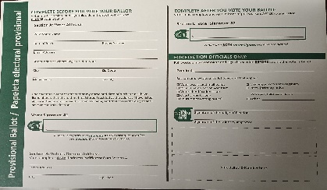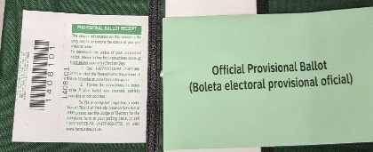
- Judge of Elections should then hand the voter a provisional ballot, Secrecy Envelope (Green), and a pen.
"Collection of materials" that will be Rubber band together: a provisional ballot affidavit envelope, secrecy envelope, and receipt sticker.
- Voter must place the completed provisional ballot in the Secrecy Envelope and place the Secrecy Envelope in the Provisional Ballot Affidavit Envelope.
- Voter must seal the Provisional Ballot Affidavit Envelope and return all materials to the Judge of Elections.
- The voter then signs the Provisional Ballot Affidavit Envelope on the line provided whereby the voter claims to be properly registered and eligible to vote at said election district. This should be completed in front of the Judge of Elections.
- Judge of Elections should fill out their section (the bottom left corner) of the Provisional Ballot Affidavit Envelope.
- Tear the Receipt Sticker along the perforated line. Affix the Receipt Sticker to the bottom left area of the Provisional Ballot Affidavit Envelope. Hand the other section of the Receipt Sticker to the voter. This contains instructions for how the voter can check the status of their provisional ballot.
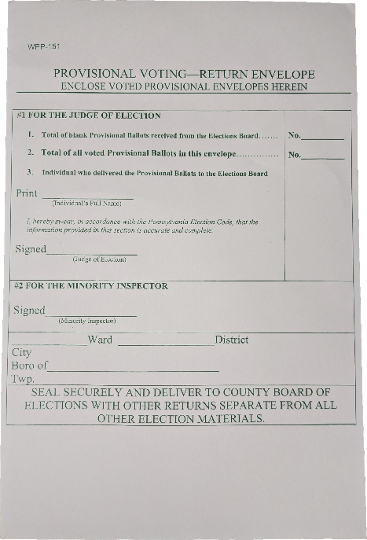
- Judge of Elections should inform the voter of the toll-free number and Internet website where the individual can learn whether their provisional ballot was counted or not counted. This information can be found on the receipt.
- Place the completed Provisional Ballot Affidavit Envelope (which now contains their completed ballot) into the large Provisional Ballot Return Envelope (White)
- Place the voters name in the NLV and mark the column labeled PROVISIONAL with an "X" to alert the Elections Office that this voter received a provisional ballot. Use RED PEN.
Provisional Ballot Return envelope where completed provisional ballot affidavit envelopes should be placed.

**Remember whether you have Provisionals Voted on not the Big White Envelope must go in the New Blue Bag Labeled Provisional at the end of the Night and Sealed.

3.13 Voting in an Emergency
There are many different types of emergencies that can happen on Election Day. Follow the guidance below in how to handle them.

3.13.1 Physical Danger/Medical Emergency
- If you feel as though you are in physical danger or a person at the polling location suffers a medical emergency, call 911. Call the Elections Office (814-471-1809) when you can.

3.13.2 Power Outage or DS200 Scanner Failure
If you cannot run ballots through the scanner, do the following:
- Notify the Elections Office (814-472-1460).
- After speaking with Election Office, remove White Seal and open the Emergency/Auxiliary Compartment on the DS200.
- While the Emergency/Auxiliary Compartment is open, lower the metal flap so ballots can be inserted while the door is closed. Then, close the door.
- Have voters place their ballots inside the Emergency Bin during the emergency period. It is very helpful to carefully tally the number of ballots being placed into the Emergency Ballot Bin Compartment. This will help to accurately reconcile the total count on the DS200 AFTER the emergency period is over.
- Once the emergency is over, open the Emergency/Auxiliary Compartment and raise the metal flap so no more ballots can be placed inside.
- Instructions on how to scan these ballots at the end of the night are in Section 4.
- New Seal (Green) must be placed on the door.
- Finally, complete the Voting Equipment Malfunction Form found in Supply Box

3.13.3 Running Low on Ballots
- Call the Elections Office (814-472-1460) and they will deliver more ballots to you. Call BEFORE you run out. The farther away you are from the Election Office, the sooner you should call.
- If you are out of standard ballots, switch over to using the Express Vote if you haven't received the replenishment.
- When you receive new ballots, retrieve all 2 copies of the General Return of Votes Cast form.
- Find the column area labeled with the type of ballot you received (Election Day, Express Vote, or Republican/Democrat if it is a primary).
- In Column B of that area, below the previous number of ballots you received, write down how many new ballots you received.

3.13.4 Evacuating the Polling Location
- If you must fully evacuate the polling location, you should make sure to take the Poll Books, NLVs, nonvoted ballots, and the DS-200 out of the polling location with you if possible.

3.14 Challenge of Voters on Election Day
Any election official, qualified voter, or watcher has the right to challenge a voter for any of the following reasons:
- Their identity.
- Their residence in the election district.
- Any alleged violation of the law pertaining to the signing of the Poll Book.
- Any alleged violation of the law prohibiting bribery at elections.
There is NO FEE for challenging a voter in the precinct.
If a voter is challenged, call the Elections Office (814-472-1460) and they will walk you through the process of completing the Challenges Electors Affidavit found in the Supply Box.

Section 4: Election Day: Poll Closing Procedures

The polls close at 8pm. Any person in line before 8 pm, either inside the polling place, can vote if they are qualified. If you have a line, put a poll worker at the end of the line so you know who the last legal voter is. If possible, pull the line inside and lock the door.
Once the last legal voter has voted, only the following people may be inside the polling place: Judge of Elections, Minority and Majority Inspectors, Clerks, Poll Watchers, & Constables (if applicable).
When it is only people with those roles in the voting area, begin the Closing Procedures Checklist.
Once you have completed Checklist 4.0 (and all checklists referenced within), all poll workers other than the Judge of Elections and Minority Inspector are finished for the day. As the other poll workers leave, the Judge of Elections and Minority Inspector will leave as well to deliver materials to Election Office, following the instructions in Section 5.
Checklist
- Lock and secure the polling location.
- 4.1 IF the Emergency Bin was used, scan all ballots within. Seal with new Green Seal.
- 4.2 Complete the General Return of Votes Cast form.
- Obtain the Closing Seal Sheet and the unused Seals from the Supplies Box.
  - Whenever you see this icon  in Section 4 checklists, seal the section as instructed and verify the number on the Closing Seal Sheet.
- 4.3 Close DS200
- 4.4 Close Express Vote Machine
- 4.5 Pack provisional ballots
- 4.6 Review Surrendered Materials
- 4.7 Pack away remaining materials including all remaining paperwork and envelopes

4.1 If the Emergency Bin was used:
Before closing the DS200, if the Emergency Bin was used, follow this process.
- Verify that your numbers are consistent prior to scanning ballots. If they are not, investigate to resolve the discrepancy.
- Two poll workers should remove all ballots that may have been deposited in this bin and scan ballot(s) through the DS200.
- The Emergency Bin will need Sealed with a new Green Seal.

4.2 Complete the General Return of Votes Cast Form
Notes:
- The header of the form will change based on the election and year type. There are four column areas at the top. Depending on the election type (primary or otherwise) more of these column areas may be filled in.
- There are three copies of this form that all must be completed.
- Column B, Line 1 should already be filled in, as you should have filled it in in the morning. You should also have additional numbers you wrote in below Line 1 if you received additional ballots of that type during the day.
- Do not leave any number field blank. Place a zero in any field that is relevant.

- General Return of Votes Cast form.
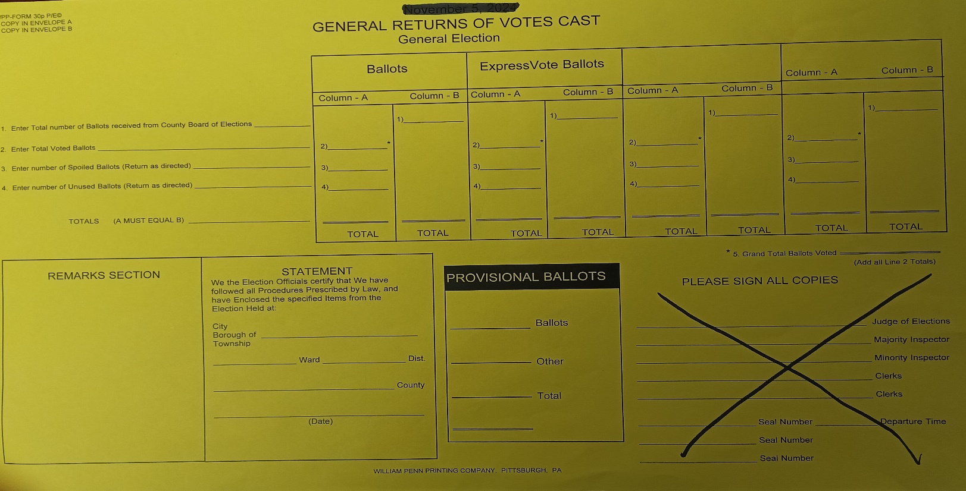
SECTION SIX
SECTION FIVE
SECTION FOUR
SECTION THREE
SECTION TWO
SECTION ONE
25
350
FOR SIGNATURES ONLY: DO NOT RECORD SEAL NUMBERS

Checklist:
- Section 1 and Section 2 – Ballot types:
  - Line 1. Column - B (Election Day) and Column - B (Express Vote Ballots) should already be filled in from earlier in the day.
    - In section 1, total all the numbers in Column B and enter that total in the “Total” line of Column B. If you did not receive additional ballots of a type during the day, Line 1 and the Total line within the same column should be the same number.
    - Repeat this process for each column area.
- Line 3. Count the number of spoiled regular ballots marked in the NLVs. Then, count the number of spoiled ballots in the Spoiled Ballot Envelope. Verify the numbers match.
    - If they do, count how many ballots are spoiled for each ballot type. Write that number on Line 3 of the appropriate section.
    - If the numbers do not match, check to see if a ballot was spoiled before the number was entered in the NLVs. Make a note in the remarks box of Section 6 to explain the discrepancy.
    - If there were no spoiled ballots for a ballot type, enter “0” on the Line 3 of that section.
  - Line 2. Fill out this line of Column A with the total ballots that were voted. To calculate this, use this formula:
    - (Ballot number of ballots issued) – (Number of votes cast (NVL) – (Provisionals) - (number of spoiled ballots) = (Total Ballots Voted)
      - Do this for each ballot type and enter your result on Line 2 in the appropriate section.
    - Then, double check your numbers. Add up the numbers on all of Lines 2. This number should match the number on the DS200. If the numbers do not match, try to determine the discrepancy. If the reason for the discrepancy cannot be found, use Section Six to explain the situation.
  - Line 4. Fill out this line of Column A with the number of unused ballots. To calculate:
    - (Ballot number of ballots issued) – (Number of votes cast (NVL) – (Provisionals) - (number of spoiled ballots) = (Total Ballots Voted)
      - Enter your result on Line 4 in the appropriate section.
  - Total all columns. Add up the numbers in each column, entering their values in the Total Line at the bottom. Column A and Column B of each section should match up. If they do not, try to identify the discrepancy. If you cannot, explain the issue in detail in the area in Section 6.
- Section 3 - Provisional Ballots by Party for Primary's:
  - Ensure the first line, the total number of ballots received is complete. If it is not, find the number on your Ballot Quantity Report and write it on the first line. You should have placed the Ballot Quantity Report in Closing the Polls Container (Clear).
  - Enter the number of ballots issued to voters.
  - Enter the number of spoiled ballots.
  - Enter the number of unused ballots.
- Section 4 - STATEMENT Precinct Information:
  - Write the precinct information and date in the Statement box.
- Section 5 - Election Board Signatures: Each member of the Election Board present will sign, attesting that the number of ballots voted, spoiled, and unused in the precinct are correct.
- Section 6 - Remarks:
  - This SECTION is VERY IMPORTANT. This is the area in which you identify any discrepancies that have occurred with ballots. YOU MUST explain any differences. The Board of Elections will be going over this report and comparing it to the Numbered list of Voters Books, DS200 results tapes and ballot quantities. If they differ in any way you will be contacted for an explanation if one isn't given in this box.
    - Feel free to use the back of this form if you need additional space to describe the discrepancies.
- Store Forms
  - Once the three copies of this form are complete, store them as follows:
    - Place one copy in Envelope A
    - Place one copy in Envelope B

4.3 Close DS200
WARNING: Removing the Election Definition Media Stick before shutdown is completed could cause damage to the DS200.
Checklist:
- Obtain the Barrel Key and the Flat Key
- Open the front Ballot Bin Compartment with the Flat key and remove the Ballot Bin.
  - Be SURE to check that all ballots have been removed from the DS200.
  - Organize ballots in a neat stack PEACH BAG
  - PLACE all UNUSED ballots, in Red Rolling Bag.
- Reseal bottom compartment with  RED Seal. Write the Seal number on the Closing Seal Sheet.
- Verify the number of ballots cast on the DS200 screen against the NLV.
- Unlock the top left access door of the DS200 with the Barrel Key.
- Press and HOLD DOWN briefly then release the “Close Poll” button.
- A confirmation screen will appear - press “Close Poll” on the DS200 screen.
- The DS200 will automatically print 4 results reports.
Top left access area with door open.
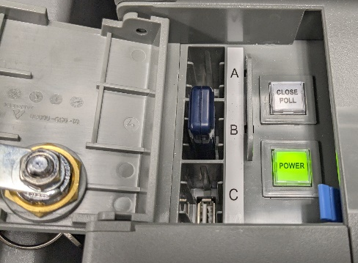
  - If you need to print additional reports, press "Report Options” and find the option that allows you to print more copies.
  - Store the 3 Results Tapes as follows:
    - Place one copy in Envelope A
    - Place one copy in Envelope B
    - Place one copy in the BLACK BAG
- Post last Results Tape outside were it can be seen after the polls are closed.
- Press “Finished - Turn Off” on the DS200 screen. The DS200 will now turn off.
- ONLY after the power button light goes out, remove the Election Definition Media Stick. Shutdown is now complete.
- PLACE the Election Definition Media Stick, in the Black Bag.
- Close and lock the left front access door. Unplug and return the power cord, close the back door and close and lock the screen and lid.
- Reseal the top compartment with  RED Seal. Write the Seal number on Closing Seal Sheet.

4.4 Close Express Vote Machine
Checklist:
- Obtain the Barrel Key
- Using the Barrel Key, open the left side access compartment.
- Flip the Power Switch to the OFF position.
- REMOVE the Election Definition Media Stick and place in the BLACK BAG
- UNPLUG the unit. Place Power Supply in the side pouch of the Black Soft-Sided Case.
- RETURN the Express Vote to the Black Soft-Sided Case. Place the headphones in the side compartment of the Black Soft-Sided Case.
- RESEAL the Express Vote with a RED Seal. Write number on Closing Seal Sheet.
- PLACE Express Vote with the DS200. They will be picked up tomorrow

4.5 Pack Provisional Ballots
Notes:
- If you have not issued any provisional ballots, see 4.5.1.
- If you have issued any provisional ballots, see 4.5.2.

4.5.1 Checklist if you did NOT issue any provisional ballots
- Ensure your Provisional Materials unused are placed in the Red Rolling Bag
- If so, complete the Provisional Voting Return Envelope Big White Envelope in the Blue Bag with Red Seal. Write number on Closing Seal Sheet.
- Return to Courthouse in (Blue Canvass Tote Bag)

4.5.2 Checklist if you DID issue any provisional ballots
- Place all UNUSED provisional ballot materials in the Provisional Materials in Red Rolling Bag
- Make sure that ALL provisional ballots are accounted for and inside the Provisional Voting Return Envelope.
  - Then, fill out and sign the front of the Provisional Voting Return Envelope and place in Blue Bag with
- Red Seal. Write number on Closing Seal Sheet.
- Return to Courthouse in (Blue Canvass Tote Bag)
- Double check section three, the “Provisional Ballots” section, of the General Return of Votes Cast form is complete before continuing.

4.6 Review Surrendered Material
Checklist:
- Make sure there is a Declaration Statement with each surrendered ballot/envelope.
- Place all surrendered ballots in the Orange Bag.
- Put the Surrendered Absentee/Mail-In Ballot Bag in the Orange Bag.

4.7 Pack Remaining Materials
Pack all remaining materials as follows. You may have already done some of these steps earlier in the day. For those steps, ensure that everything is in its correct final location.
- Election Officers’ Oaths Forms. You should have two copies. If you have not already done so, do the following:
  - Place one copy in Envelope G.
    - Then, place Envelope G into Envelope A.
  - Place one copy in Envelope H.
    - Then, place Envelope H into Envelope B.
- Zero Tapes. You should have three copies of the Zero Tapes from the beginning of the day.
  - Place one copy in Envelope A. (If you have not already done so)
  - Place one copy in Envelope B. (If you have not already done so)
  - Ensure that one copy is placed in the Black Bag
- Results Tapes. You should have three copies of the Result Tapes after closing the DS200.
  - Place one copy in Envelope A.
  - Place one copy in Envelope B.
  - Ensure that one copy is placed in the Black Bag
- Affidavit of Voter Identification. You should have one copy of this form.
  - Place sole copy in Envelope A (if you have not already done so).
- Affirmation of Elector Envelope
  - All completed Affirmation of Elector forms should be inside this envelope. Then, place this envelope into Envelope A.
- Pay Sheet Place in your Blue Canvass Tote Bag
- Record of Assisted voters form(s). You should have 1 copy of this form.
  - Place form(s) in Envelope K.
  - Place Envelope K in Envelope A.
- Declaration of the Need for Assistance to Vote form(s). You should have one form for each voter that requested assistance.
  - Place all forms in Envelope A.
- Poll Book
  - Place Poll Book(s) in the Blue Canvass Tote Bag
- Supply Box (White).
  - Place all remaining paper materials in the Supply Box
  - Place in the Red Rolling bag
- NLV
  - Place one copy in Envelope A.
  - Place one copy in Envelope B.
- Remaining other materials.
  - Take down any tables and return them to where you found them.

4.8 Seal Election Supply Bag (Red Rolling Bag), (Peach), (Orange) (Black)
- BEFORE sealing Election Supply Bag (Red Rolling Bag).
  - Ensure the main pocket of the bag contains:
    - The Unused Ballots
    - the Unused Provisionals / Unused Provisional Materials: Not the White Provisional Envelope
    - the Supply Box
    - Any other Unused Supplies
  - Then, seal with a RED Seal . Write number on Closing Seal Sheet.
  - Envelope A containing:
- 1 General Return of Votes Cast
- 1 Zero Tape
- 1 Results Tape
- 1 NLV
- Affirmation of Electors Envelope
- Affidavit of Voter Identification
- Declaration of Need for Assistance to Vote (if applicable)
- Envelope G containing Election Officers’ Oath Form
- Envelope K containing Record of Assisted Voter form (if applicable)
  - Orange Bag
    - Surrendered Ballots / Surrendered Ballot Forms
    - Unused Surrendered Ballot Forms
  - Then, seal with a Red Seal. Write number on Closing Seal Sheet
  - Peach Bag
- Voted ballots
- Spoiled Ballots / Spoiled Envelopes
  - Then, seal with a Red Seal. Write number on Closing Seal Sheet
  - Blue Bag
- Provisional White envelope – Used or Unused
- Then, seal with a Red Seal. Write number on Closing Seal Sheet
  - Black Bag
- 1 DS200 Results Media Stick
- 1 Express Vote Media Stick
- 1 Zero Tape
- 1 Results Tape
- Keys
- Blue Canvass Tote Bag
- Orange Bag
- Peach Bag
- Blue Bag
- Black Bag
- Envelope A
- Envelope C
- Poll Books
- Pay sheet
- Opening Seal Sheet/ Closing Seal Sheet

