Cambria County Vector Control

Mosquito Disease Control Program

Cambria County Mosquito Disease Control program conducts surveillance throughout the county during the months of May through October annually.

Mosquito traps are set in public areas and private properties with homeowner

permission.

The mosquito traps are typically set for 24 hours and are labelled with identification tags. Examples of the traps/labels are shown below.

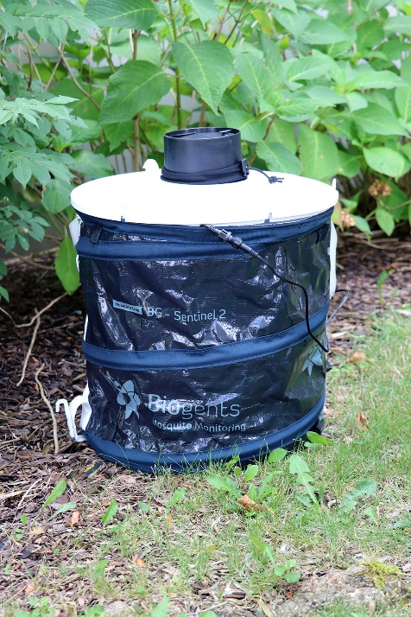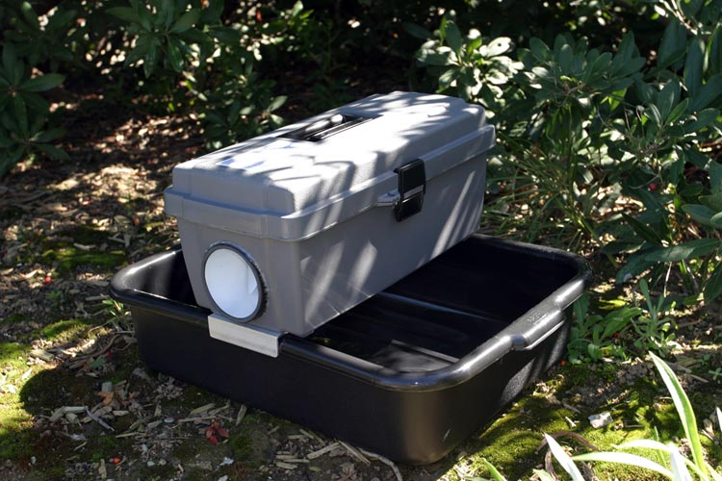

If you have questions or would like to learn more about our program, please contact us:

Cambria County Vector Control

110 Franklin Street, Suite 300

Johnstown, PA 15901

www.cambriacountypa.gov/vector-control/

(814) 322-8941

BG Sentinel Trap

**MOSQUITO TRAP**

**CAMBRIA COUNTY MOSQUITO CONTROL PROGRAM**

**(814)322-8941**

Gravid Trap